**Project Design Phase**

**Solution Architecture**

|  |  |
| --- | --- |
| Date | 27 June 2025 |
| Team ID | LTVIP2025TMID59297 |
| Project Name | Smart Sorting: Transfer Learning for Identifying Rotten Fruits and Vegetables |
| Maximum Marks | 4 Marks |

**Solution Architecture:**

Solution architecture is a complex process – with many sub-processes – that bridges the gap between business problems and technology solutions. Its goals are to:

● Find the best tech solution to solve existing business problems.  
→ Implement a deep learning–based image classification system using transfer learning to accurately detect and classify rotten vs. fresh fruits/vegetables, addressing inefficiencies in manual sorting.

● Describe the structure, characteristics, behaviour, and other aspects of the software to project stakeholders.  
→ The system comprises components such as image input (camera/UI), model inference engine, sorting/display interface, and storage/logging. Images are captured, processed, classified, and then routed or logged based on classification results.

● Define features, development phases, and solution requirements.  
→ Key features include image upload or real-time capture, automatic freshness detection, visual dashboard or hardware-based sorting, and database logging. Development phases include data collection, model training, backend integration, and deployment.

**Example - Solution Architecture Diagram:**

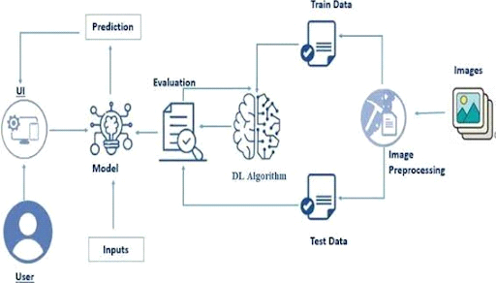

*Figure 1: Architecture of Smart Sorting: Transfer Learning for Identifying Rotten Fruits and Vegetables*

**Reference:**

* A Deep Learning Approach to Fruit and Vegetable Classification: Fresh or Rotten” by Gulsum Kayhan (Medium, May 19, 2025) – this blog clearly outlines a transfer‑learning project using ResNet to classify 14 types of fresh vs rotten produce, with implementation details and visuals